

CONVOLUTIONAL NEURAL

# NETWORK

Vairavan M

Saranathan College of engineering

Friday, 14 July 2023

**Convolutional Neural Network (CNN)**

A Convolutional Neural Network (CNN) is a type of Deep Learning neural network architecture commonly used in Computer Vision. Computer vision is a field of Artificial Intelligence that enables a computer to understand and interpret the image or visual data.

A CNN is a kind of network architecture for deep learning algorithms and is specifically used for image recognition and tasks that involve the processing of pixel data. There are other types of neural networks in deep learning, but for identifying and recognizing objects, CNNs are the network architecture of choice.

## Examples of CNN

Examples of CNN in computer vision are face recognition, image classification etc. It is similar to the basic neural network. CNN also have learnable parameter like neural network i.e., weights, biases etc.

## Four components of CNN

. There are four types of layers for a convolutional neural network:

1. the convolutional layer,
2. the pooling layer, 3. the ReLU correction layer

4. Fully-connected layer.

### The convolutional layer

The convolutional layer is the key component of convolutional neural networks, and is always at least their first layer.

### The pooling layer

This type of layer is often placed between two layers of convolution: it receives several feature maps and applies the pooling operation to each of them.

### The ReLU correction layer

The ReLU correction layer replaces all negative values received as inputs by zeros. It acts as an activation function.

#### The fully-connected layer

The fully-connected layer is always the last layer of a neural network, convolutional or not — so it is not characteristic of a CNN.

## The applications of CNN

1).Image Classification – Search Engines, Social Media, Recommender Systems.

The major use of convolutional neural networks is image recognition and classification.

It is also the only use case involving the most advanced frameworks (especially, in the case of medical imaging).

2).Decoding Facial Recognition •Identifying every face in the picture.

* Focusing on each face despite external factors, such as light, angle, pose, etc.
* Identifying unique features.
* Comparing all the collected data with already existing data in the database to match a face with a name.

### Assignment Description

Build a convolutional neural network for image classification using a dataset of your choice (e.g., CIFAR-10). Train the network and evaluate its performance in terms of accuracy. Discuss the impact of different architectural choices (e.g., number of layers, filter sizes) on the network's performance.

### Solution

1). Discuss the impact of different architectural choices (e.g., number of layers, filter sizes) on the network's performance.

Answer:

**Localized Features**: Smaller filter sizes allow the network to capture more localized features in the input data. This is because smaller filters focus on smaller regions of the input, enabling the network to learn finegrained patterns and details.

**Parameter Efficiency**: Smaller filter sizes typically have fewer parameters compared to larger filters. This can make the network more computationally efficient and reduce the risk of over fitting, especially when working with limited training data.

**Translation Invariance**: CNNs are known for their ability to exhibit translation invariance, which means they can recognize patterns regardless of their spatial position in the input. Smaller filters contribute to this property by capturing local patterns across different regions of the input, improving the network's ability to generalize.

**Spatial Hierarchy**: While smaller filters excel at capturing localized features, larger filters tend to capture more global or context-rich information. Combining filters of different sizes (e.g., using filter banks or parallel filter branches) allows the network to capture features at multiple spatial scales, creating a spatial hierarchy of representations.

**Network Depth**: The choice of filter sizes can also influence the depth of the network. Smaller filters are often used in deeper architectures, as stacking multiple layers with small filters can emulate the receptive fields of larger filters. This depth can help capture increasingly complex patterns and improve the network's performance.

It's important to note that the optimal filter size can vary depending on the specific task and dataset. Designing an effective network architecture often involves experimentation and tuning different hyper parameters, including filter sizes, to achieve the best performance for the given problem.

2). Build a convolutional neural network for image classification using a dataset of your choice (e.g., CIFAR-10). Train the network and evaluate its performance in terms of accuracy.

Step 1:

Import all the required libraries and modules



Step 2:

Load the data and split it into train and test data



Step 3

Rearrange them in form of a row



Step 4:

To see few images of our dataset.



CNN to train our model and normalize



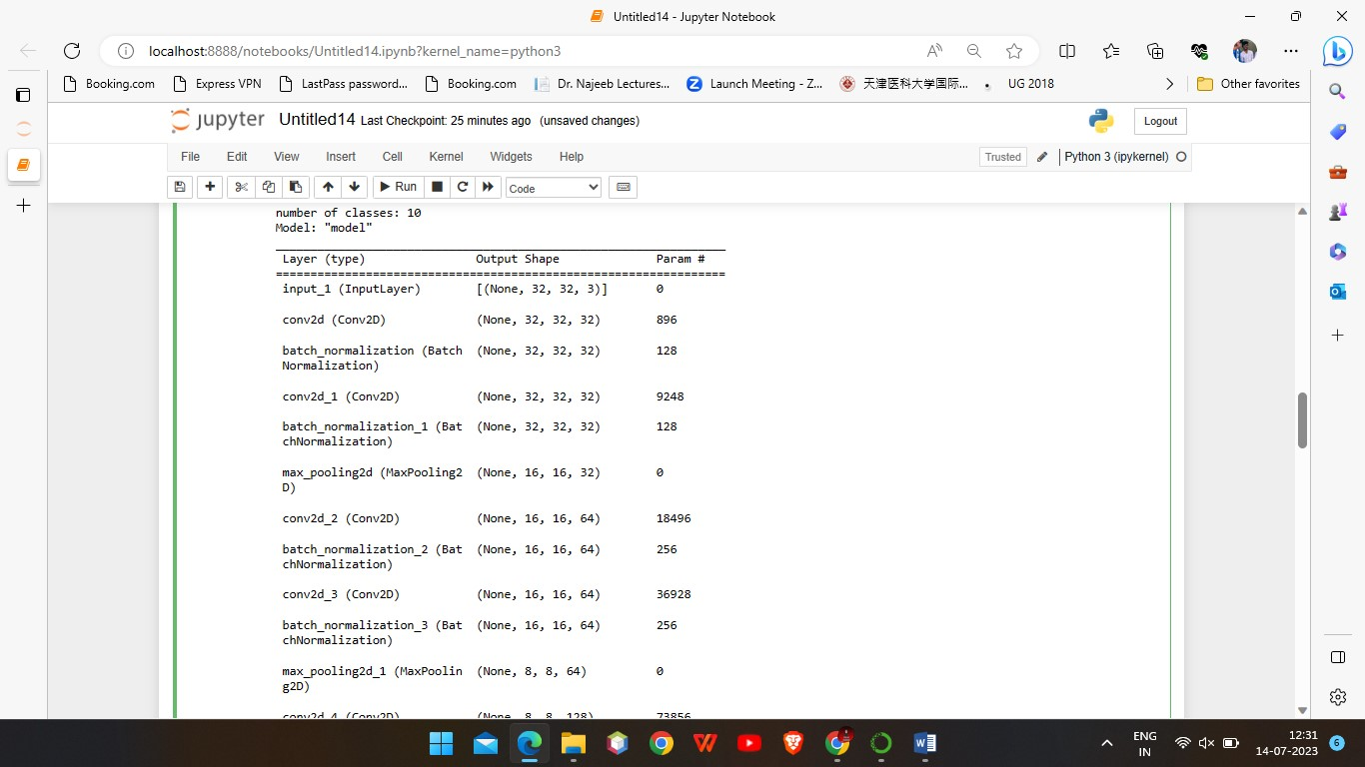

Compile the model and fit



Step 7:

Visualize the accuracy per iteration



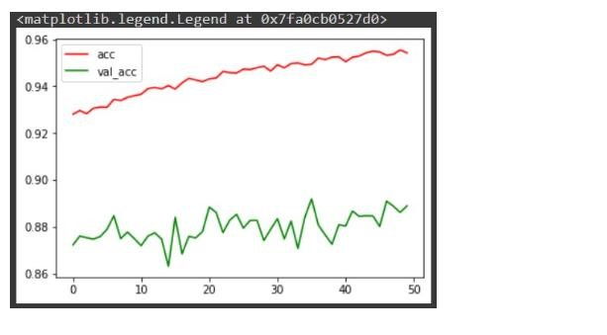

Make a prediction over an image from our model





Thank you!!!!!!!!